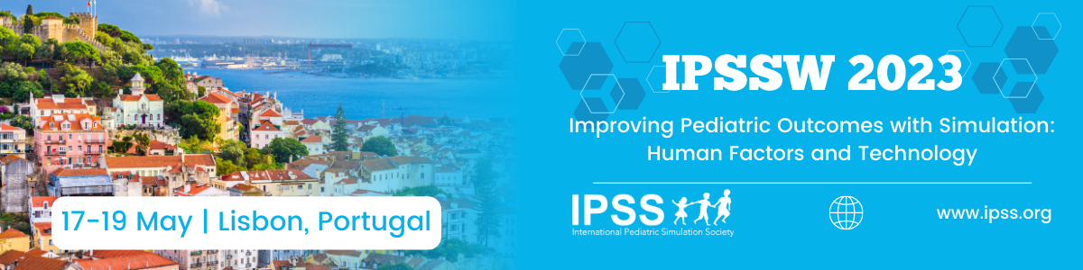

Ideas and Works in Progress Abstract Submission Template for IPSSW2023

Abstracts are limited to 3000 characters including spaces and not including author names and affiliations or references.

For inclusion in the Conference Proceedings please bear in mind the following:
- Abstracts and proposals must be submitted electronically via on-line submission link: https://app.oxfordabstracts.com/stages/4909/submitter
  - The title should be no longer than 100 characters.
  - Graphs, tables and illustrations are allowed to be submitted as part of the abstract.

Please provide some or all of the elements described below, either in a structured or unstructured format (please adapt as you see fit):

Title:

Discussant:

Background:

Research Question/ Educational Goal:

Proposed Approach to Addressing the Question or Goal:

Conundrum or Difficulty Encountered:

Questions for Discussion:

